**Inhomogeneous Elasticity**

We previously assumed that the elastic constant was spatially independent. Now let us consider what happens when the elastic tensor is spatially dependent:

$$C_{ijkl}\left(\vec{x}\right)=C_{ijkl}^{0}+∆C_{ijkl}\left(\vec{x}\right)$$

The stress is:

$$σ_{ij}\left(\vec{x}\right)=C_{ijkl}\left(\vec{x}\right)\left(ε_{kl}\left(\vec{x}\right)-ε_{kl}^{0}\left(\vec{x}\right)\right)=\left(C_{ijkl}^{0}+∆C_{ijkl}\left(\vec{x}\right)\right)\left(ε_{kl}\left(\vec{x}\right)-ε_{kl}^{0}\left(\vec{x}\right)\right)$$

Mechanical equilibrium is given by:

$$\frac{∂σ_{ij}\left(\vec{x}\right)}{∂x_{j}}=\frac{∂}{∂x_{j}}\left[\left(C_{ijkl}^{0}+∆C_{ijkl}\left(\vec{x}\right)\right)\left(ε_{kl}\left(\vec{x}\right)-ε_{kl}^{0}\left(\vec{x}\right)\right)\right]=0$$

$$ε_{kl}\left(\vec{x}\right)={\overline{ε}}_{kl}+δε_{kl}\left(\vec{x}\right)$$

$$\int{δε_{kl}\left(\vec{x}\right)}dV=0$$

${\overline{ε}}_{kl}$ is specified by macroscopic boundary conditions

$$δε_{kl}\left(\vec{x}\right)=\frac{1}{2}\left(\frac{∂u_{k}\left(\vec{x}\right)}{∂x_{l}}+\frac{∂u_{l}\left(\vec{x}\right)}{∂x_{k}}\right)$$

Mechanical equilibrium now becomes:

$$\frac{∂}{∂x_{j}}\left[\left(C_{ijkl}^{0}+∆C_{ijkl}\left(\vec{x}\right)\right)\left({\overline{ε}}_{kl}+\frac{1}{2}\left(\frac{∂u_{k}\left(\vec{x}\right)}{∂x_{l}}+\frac{∂u_{l}\left(\vec{x}\right)}{∂x_{k}}\right)-ε_{kl}^{0}\left(\vec{x}\right)\right)\right]=0$$

Application of the product rule gives:

$$\left(\frac{∂}{∂x_{j}}\left[\left(C_{ijkl}^{0}+∆C_{ijkl}\left(\vec{x}\right)\right)\right]\right)\left({\overline{ε}}_{kl}+\frac{1}{2}\left(\frac{∂u_{k}\left(\vec{x}\right)}{∂x_{l}}+\frac{∂u_{l}\left(\vec{x}\right)}{∂x_{k}}\right)-ε_{kl}^{0}\left(\vec{x}\right)\right)+\left(C_{ijkl}^{0}+∆C_{ijkl}\left(\vec{x}\right)\right)\left(\frac{∂}{∂x_{j}}\left[{\overline{ε}}_{kl}+\frac{1}{2}\left(\frac{∂u_{k}\left(\vec{x}\right)}{∂x_{l}}+\frac{∂u_{l}\left(\vec{x}\right)}{∂x_{k}}\right)-ε_{kl}^{0}\left(\vec{x}\right)\right]\right)=0$$

Let

$$C_{ijkl}^{0}=C_{klij}^{0},∆C_{ijkl}=∆C_{klij}$$

$$C_{ijkl}^{0}=C_{jikl}^{0},∆C_{ijkl}=∆C_{jikl}$$

$$C_{ijkl}^{0}=C_{ijlk}^{0},∆C_{ijkl}=∆C_{ijlk}$$

$$C_{ijkl}u_{k,l}=C_{ijkl}u_{l,k}$$

The first term is:

$$\left(\frac{∂}{∂x_{j}}\left[\left(C_{ijkl}^{0}+∆C_{ijkl}\left(\vec{x}\right)\right)\right]\right)\left({\overline{ε}}_{kl}+\frac{1}{2}\left(\frac{∂u_{k}\left(\vec{x}\right)}{∂x_{l}}+\frac{∂u_{l}\left(\vec{x}\right)}{∂x_{k}}\right)-ε_{kl}^{0}\left(\vec{x}\right)\right)$$

$$\frac{∂∆C_{ijkl}\left(\vec{x}\right)}{∂x_{j}}\left({\overline{ε}}_{kl}+\frac{1}{2}\left(\frac{∂u_{k}\left(\vec{x}\right)}{∂x_{l}}+\frac{∂u_{l}\left(\vec{x}\right)}{∂x_{k}}\right)-ε_{kl}^{0}\left(\vec{x}\right)\right)=\frac{∂∆C_{ijkl}\left(\vec{x}\right)}{∂x_{j}}\left({\overline{ε}}_{kl}+\frac{∂u_{k}\left(\vec{x}\right)}{∂x_{l}}-ε_{kl}^{0}\left(\vec{x}\right)\right)$$

$$\frac{∂∆C_{ijkl}\left(\vec{x}\right)}{∂x_{j}}\frac{∂u_{k}\left(\vec{x}\right)}{∂x_{l}}=\frac{∂∆C_{ijkl}\left(\vec{x}\right)}{∂x_{j}}\frac{∂u_{l}\left(\vec{x}\right)}{∂x_{k}}$$

The second term is:

$$\left(C_{ijkl}^{0}+∆C_{ijkl}\left(\vec{x}\right)\right)\left(\frac{∂}{∂x_{j}}\left[{\overline{ε}}_{kl}+\frac{1}{2}\left(\frac{∂u_{k}\left(\vec{x}\right)}{∂x_{l}}+\frac{∂u_{l}\left(\vec{x}\right)}{∂x_{k}}\right)-ε_{kl}^{0}\left(\vec{x}\right)\right]\right)=\left(C_{ijkl}^{0}+∆C_{ijkl}\left(\vec{x}\right)\right)\left(\frac{∂}{∂x_{j}}\left[\frac{∂u_{k}\left(\vec{x}\right)}{∂x_{l}}-ε_{kl}^{0}\left(\vec{x}\right)\right]\right)$$

$$C_{ijkl}\frac{∂u_{k}\left(\vec{x}\right)}{∂x_{j}∂x_{l}}=C_{ijkl}\frac{∂u_{l}\left(\vec{x}\right)}{∂x_{j}∂x_{k}}$$

The mechanical equilibrium reads:

$$\frac{∂∆C_{ijkl}\left(\vec{x}\right)}{∂x_{j}}\left({\overline{ε}}_{kl}+\frac{∂u_{k}\left(\vec{x}\right)}{∂x_{l}}-ε_{kl}^{0}\left(\vec{x}\right)\right)+\left(C_{ijkl}^{0}+∆C_{ijkl}\left(\vec{x}\right)\right)\left(\frac{∂}{∂x_{j}}\left[\frac{∂u_{k}\left(\vec{x}\right)}{∂x_{l}}-ε_{kl}^{0}\left(\vec{x}\right)\right]\right)=0$$

$$C_{ijkl}^{0}\frac{∂u_{k}\left(\vec{x}\right)}{∂x_{j}∂x_{l}}=-\frac{∂∆C_{ijkl}\left(\vec{x}\right)}{∂x_{j}}\left({\overline{ε}}_{kl}+\frac{∂u_{k}\left(\vec{x}\right)}{∂x_{l}}-ε_{kl}^{0}\left(\vec{x}\right)\right)+\left(C_{ijkl}^{0}+∆C_{ijkl}\left(\vec{x}\right)\right)\frac{∂ε_{kl}^{0}\left(\vec{x}\right)}{∂x_{j}}-∆C_{ijkl}\left(\vec{x}\right)\frac{∂u_{k}\left(\vec{x}\right)}{∂x_{j}∂x_{l}}$$

$$=\frac{∂∆C_{ijkl}\left(\vec{x}\right)}{∂x_{j}}\left(ε_{kl}^{0}\left(\vec{x}\right)-{\overline{ε}}_{kl}-\frac{∂u_{k}\left(\vec{x}\right)}{∂x_{l}}\right)+\left(C_{ijkl}^{0}+∆C_{ijkl}\left(\vec{x}\right)\right)\frac{∂ε_{kl}^{0}\left(\vec{x}\right)}{∂x_{j}}-∆C_{ijkl}\left(\vec{x}\right)\frac{∂u_{k}\left(\vec{x}\right)}{∂x_{j}∂x_{l}}$$

The right-hand side is equivalent to:

$$\frac{∂}{∂x_{j}}\left[\left(C_{ijkl}^{0}+∆C_{ijkl}\left(\vec{x}\right)\right)\left(ε_{kl}^{0}\left(\vec{x}\right)-{\overline{ε}}_{kl}\right)\right]-\frac{∂}{∂x_{j}}\left[∆C_{ijkl}\left(\vec{x}\right)\frac{∂u_{k}\left(\vec{x}\right)}{∂x_{l}}\right]$$

To see this, let us expand:

$$\frac{∂}{∂x_{j}}\left[\left(C_{ijkl}^{0}+∆C_{ijkl}\left(\vec{x}\right)\right)\left(ε_{kl}^{0}\left(\vec{x}\right)-{\overline{ε}}_{kl}\right)\right]=\frac{∂∆C_{ijkl}\left(\vec{x}\right)}{∂x_{j}}\left(ε_{kl}^{0}\left(\vec{x}\right)-{\overline{ε}}_{kl}\right)+\left(C_{ijkl}^{0}+∆C_{ijkl}\left(\vec{x}\right)\right)\left[\frac{∂ε_{kl}^{0}\left(\vec{x}\right)}{∂x_{j}}\right]$$

$$\frac{∂}{∂x_{j}}\left[∆C_{ijkl}\left(\vec{x}\right)\frac{∂u_{k}\left(\vec{x}\right)}{∂x_{l}}\right]=\frac{∂∆C_{ijkl}\left(\vec{x}\right)}{∂x_{j}}\frac{∂u_{k}\left(\vec{x}\right)}{∂x_{l}}+∆C_{ijkl}\left(\vec{x}\right)\frac{∂u_{k}\left(\vec{x}\right)}{∂x_{j}∂x_{l}}$$

$$\frac{∂∆C_{ijkl}\left(\vec{x}\right)}{∂x_{j}}\left(ε_{kl}^{0}\left(\vec{x}\right)-{\overline{ε}}_{kl}\right)+\left(C_{ijkl}^{0}+∆C_{ijkl}\left(\vec{x}\right)\right)\frac{∂ε_{kl}^{0}\left(\vec{x}\right)}{∂x_{j}}-\frac{∂∆C_{ijkl}\left(\vec{x}\right)}{∂x_{j}}\frac{∂u_{k}\left(\vec{x}\right)}{∂x_{l}}-∆C_{ijkl}\left(\vec{x}\right)\frac{∂u_{k}\left(\vec{x}\right)}{∂x_{j}∂x_{l}}$$

$$\frac{∂∆C_{ijkl}\left(\vec{x}\right)}{∂x_{j}}\left(ε_{kl}^{0}\left(\vec{x}\right)-{\overline{ε}}_{kl}-\frac{∂u_{k}\left(\vec{x}\right)}{∂x_{l}}\right)+\left(C_{ijkl}^{0}+∆C_{ijkl}\left(\vec{x}\right)\right)\frac{∂ε_{kl}^{0}\left(\vec{x}\right)}{∂x_{j}}-∆C_{ijkl}\left(\vec{x}\right)\frac{∂u_{k}\left(\vec{x}\right)}{∂x_{j}∂x_{l}}$$

$$=\frac{∂∆C_{ijkl}\left(\vec{x}\right)}{∂x_{j}}\left(ε_{kl}^{0}\left(\vec{x}\right)-{\overline{ε}}_{kl}-\frac{∂u_{k}\left(\vec{x}\right)}{∂x_{l}}\right)+\left(C_{ijkl}^{0}+∆C_{ijkl}\left(\vec{x}\right)\right)\frac{∂ε_{kl}^{0}\left(\vec{x}\right)}{∂x_{j}}-∆C_{ijkl}\left(\vec{x}\right)\frac{∂u_{k}\left(\vec{x}\right)}{∂x_{j}∂x_{l}}$$

$$C_{ijkl}^{0}\frac{∂u_{k}\left(\vec{x}\right)}{∂x_{j}∂x_{l}}=\frac{∂}{∂x_{j}}\left[\left(C_{ijkl}^{0}+∆C_{ijkl}\left(\vec{x}\right)\right)\left(ε_{kl}^{0}\left(\vec{x}\right)-{\overline{ε}}_{kl}\right)\right]-\frac{∂}{∂x_{j}}\left[∆C_{ijkl}\left(\vec{x}\right)\frac{∂u_{k}\left(\vec{x}\right)}{∂x_{l}}\right]$$

The equation is of the form:

$$C_{ijkl}^{0}\frac{∂u_{k}\left(\vec{x}\right)}{∂x_{j}∂x_{l}}=\frac{∂}{∂x_{j}}{RHS}_{ij}\left\{u_{k}\right\}$$

$${RHS}_{ij}\left\{u_{k}\right\}=\left(C_{ijkl}^{0}+∆C_{ijkl}\left(\vec{x}\right)\right)\left(ε_{kl}^{0}\left(\vec{x}\right)-{\overline{ε}}_{kl}\right)-∆C_{ijkl}\left(\vec{x}\right)\frac{∂u_{k}\left(\vec{x}\right)}{∂x_{l}}$$

There are three independent PDEs that we must solve ($i=1,2,3$)

First we make a zero-order approximation, in which $∆C_{ijkl}=0,$

$$C_{ijkl}^{0}\frac{∂u_{k}^{0}\left(\vec{x}\right)}{∂x_{j}∂x_{l}}=C_{ijmn}^{0}\frac{∂ε_{mn}^{0}\left(\vec{x}\right)}{∂x_{j}}$$

$${\hat{u}}_{k}^{0}=-iξ_{j}Ω_{ki}C_{ijmn}{\hat{ε}}_{mn}^{0}$$

Now substitute this zero-order solution into the original PDE to obtain. This is our iterative scheme, we solve for the first-order approximation $u_{k}^{1}$ by using in the right-hand-side the zero-order solution $u_{k}^{0}$

$$C_{ijkl}^{0}\frac{∂u_{k}^{1}\left(\vec{x}\right)}{∂x_{j}∂x_{l}}=\frac{∂}{∂x_{j}}{RHS}_{ij}\left\{u_{k}^{0}\right\}$$

$${\hat{u}}_{k}^{1}=-iξ_{j}Ω_{ki}{\hat{RHS}}_{ij}$$

Successive iterations can be obtained by solving:

$$C_{ijkl}^{0}\frac{∂u_{k}^{n}\left(\vec{x}\right)}{∂x_{j}∂x_{l}}=\frac{∂}{∂x_{j}}{RHS}_{ij}\left\{u_{k}^{n-1}\right\}$$

$${\hat{u}}_{k}^{n}=-iξ_{j}Ω_{ki}{\hat{RHS}}_{ij}$$

$${\hat{RHS}}_{ij}=F\left\{\left(C_{ijmn}^{0}+∆C_{ijmn}\left(\vec{x}\right)\right)\left(ε_{mn}^{0}\left(\vec{x}\right)-{\overline{ε}}_{mn}\right)-∆C_{ijmn}\left(\vec{x}\right)\frac{∂u_{m}^{n-1}\left(\vec{x}\right)}{∂x_{n}}\right\}$$

As the number of iterations increases ${\hat{u}}_{k}^{n}$ should converge to a solution for the displacement field.

To test our numerical implementation we expanded the left and right-hand sides of the below equation for $i=1,2,3$: $$C_{ijkl}^{0}\frac{∂u_{k}\left(\vec{x}\right)}{∂x_{j}∂x_{l}}=\frac{∂}{∂x_{j}}\left[\left(C_{ijkl}^{0}+∆C_{ijkl}\left(\vec{x}\right)\right)\left(ε_{kl}^{0}\left(\vec{x}\right)-{\overline{ε}}_{kl}\right)\right]-\frac{∂}{∂x_{j}}\left[∆C_{ijkl}\left(\vec{x}\right)\frac{∂u_{k}\left(\vec{x}\right)}{∂x_{l}}\right]$$

Once we solve for $u_{k}$ the left and right hand sides should be identical.

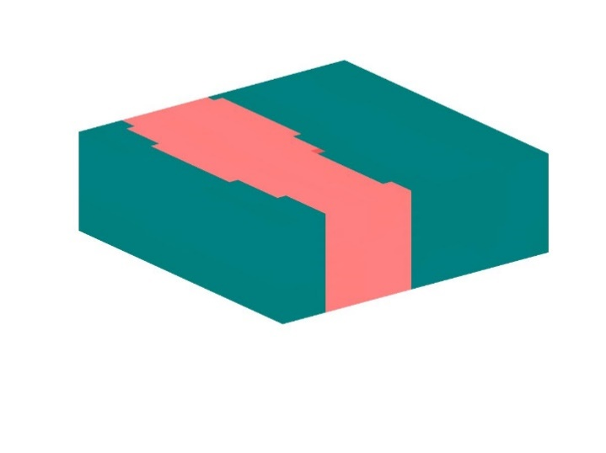

We tested our solution on the above polarization distribution. The image above is just the film, it is surrounded by non-polarizable air and substrate layers in the z-direction. We also define the difference between the LHS and RHS using $r^{2}:$

$$r^{2}=1-\frac{\sum_{\vec{x}}{{\left(LHS\left(\vec{x}\right)-RHS\left(\vec{x}\right)\right)}^{2}}}{\sum_{\vec{x}}{{\left(LHS\left(\vec{x}\right)-\overline{LHS}\right)}^{2}}},\overline{LHS}=\sum_{\vec{x}}{LHS\left(\vec{x}\right)}$$

First, let us test the case of a homogenous elastic tensor ($∆C_{ijkl}=0$):

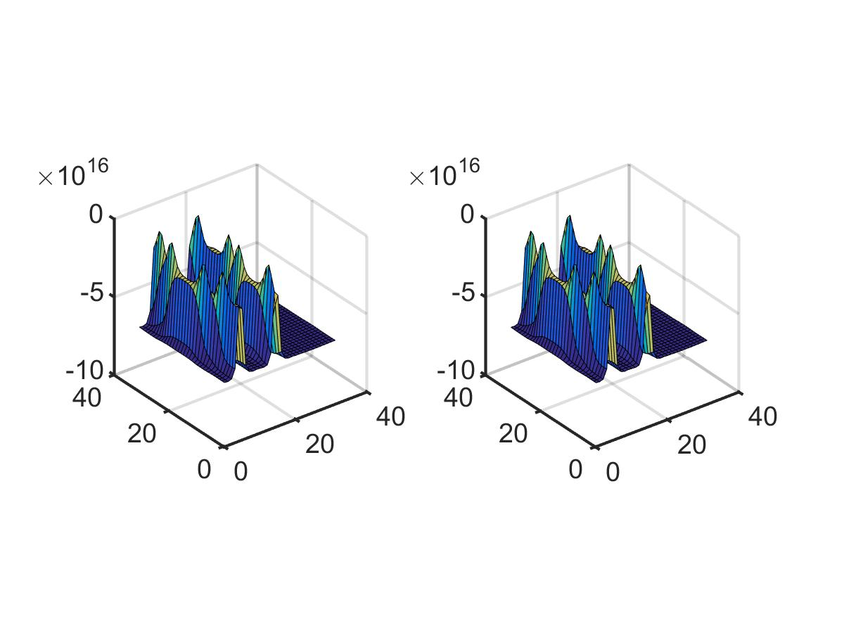

One layer of the LHS (left) and RHS (right). $r^{2}=1.$

Now we test the case of an inhomogeneous elastic tensor. We define three different elastic tensors $C_{sub}, C_{film},C_{air}.$ All are described by an anisotropic cubic elastic tensor.

|  |  |  |  |  |  |  |  |  |
| --- | --- | --- | --- | --- | --- | --- | --- | --- |
| $$C_{sub} ({10}^{11}Pa)$$ | | | $$C_{film} ({10}^{11}Pa)$$ | | | $$C_{air} ({10}^{11}Pa)$$ | | |
| 5 | 1.5 | 2.5 | 2.4 | 1 | 1.24 | 0 | 0 | 0 |

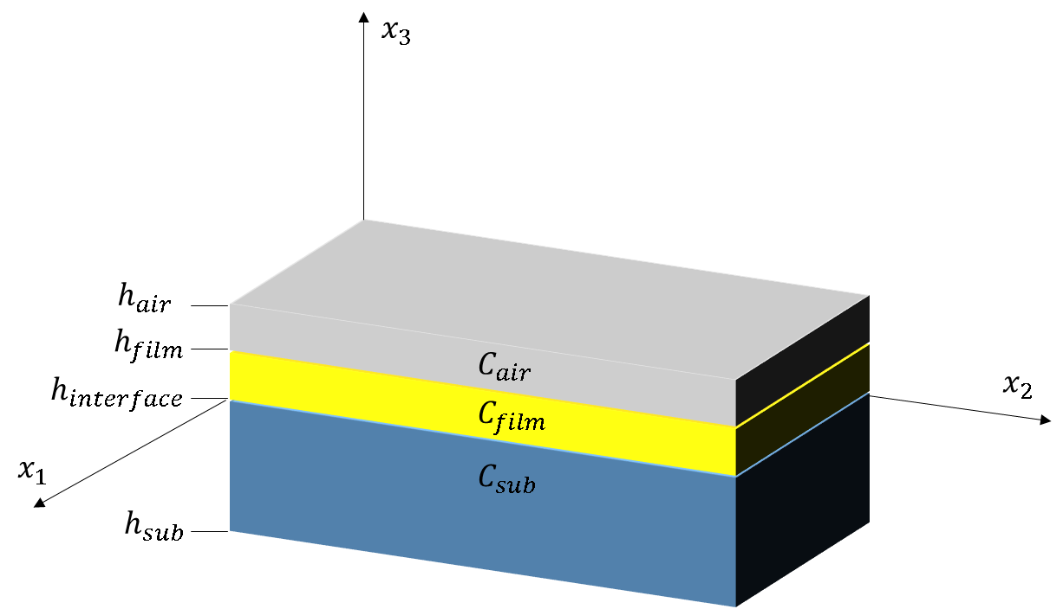

$C_{ijkl}\left(\vec{x}\right)$ is the spatially varying elastic tensor.

$$C_{ijkl}^{0}=\sum_{\vec{x}}{C_{ijkl}\left(\vec{x}\right)}$$

$$∆C_{ijkl}\left(\vec{x}\right)=C_{ijkl}(\vec{x})-\sum_{\vec{x}}{C_{ijkl}\left(\vec{x}\right)}$$

For a zero-order approximation (no iterations via the iterative-perturbation scheme) $r^{2}=0.517$:

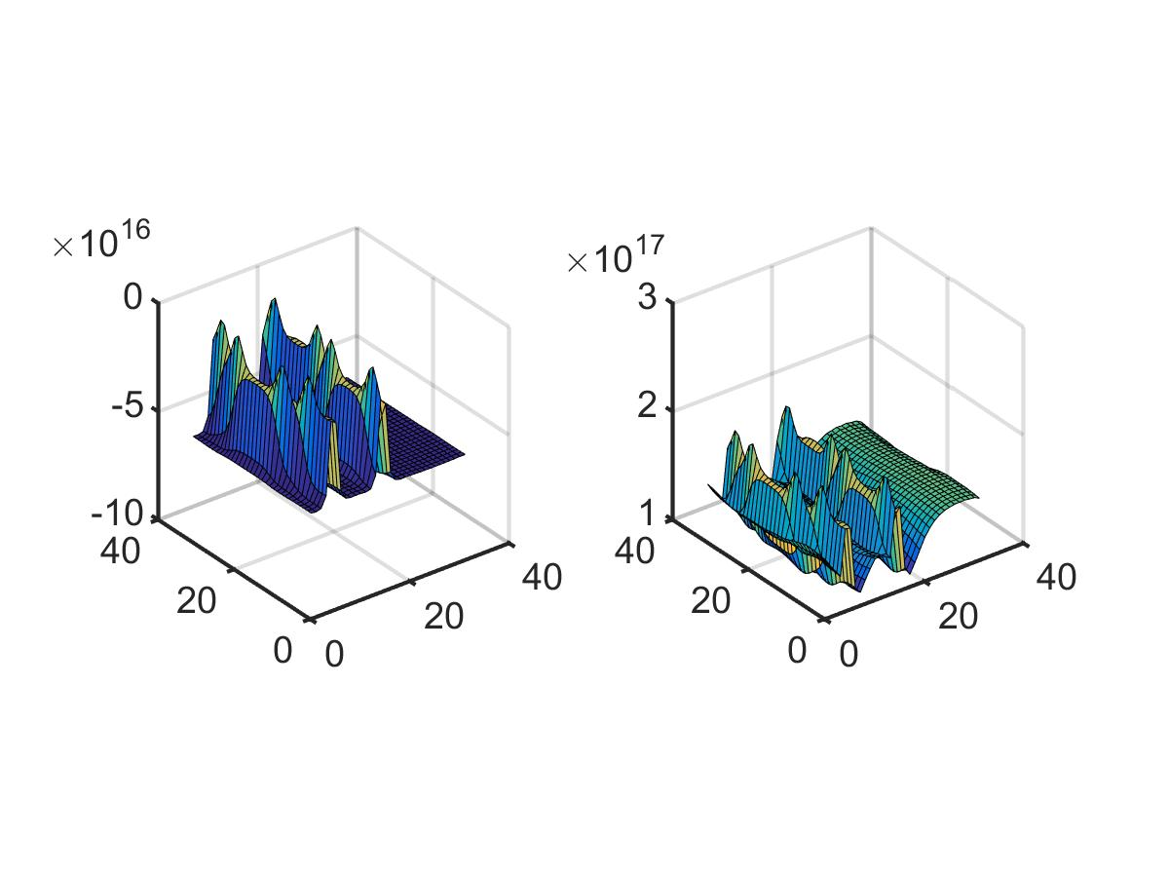

For a fifth-order approximation $r^{2}=0.990$

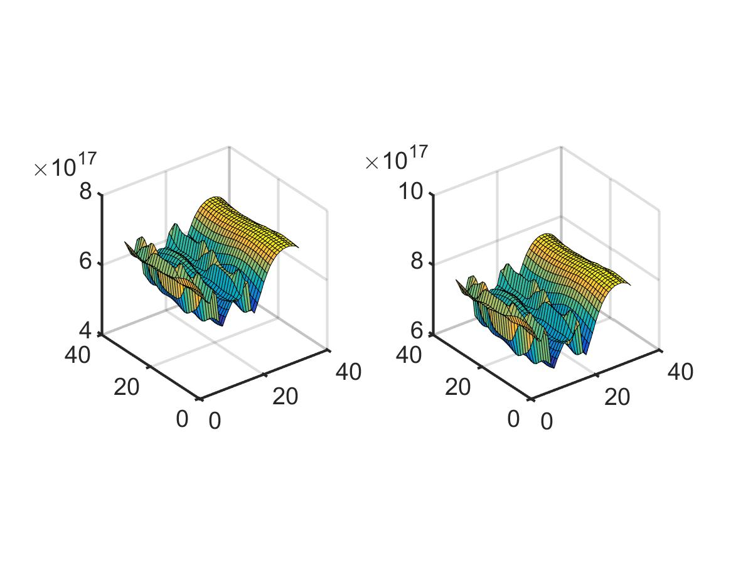

For a fifth-order approximation $r^{2}=0.999$

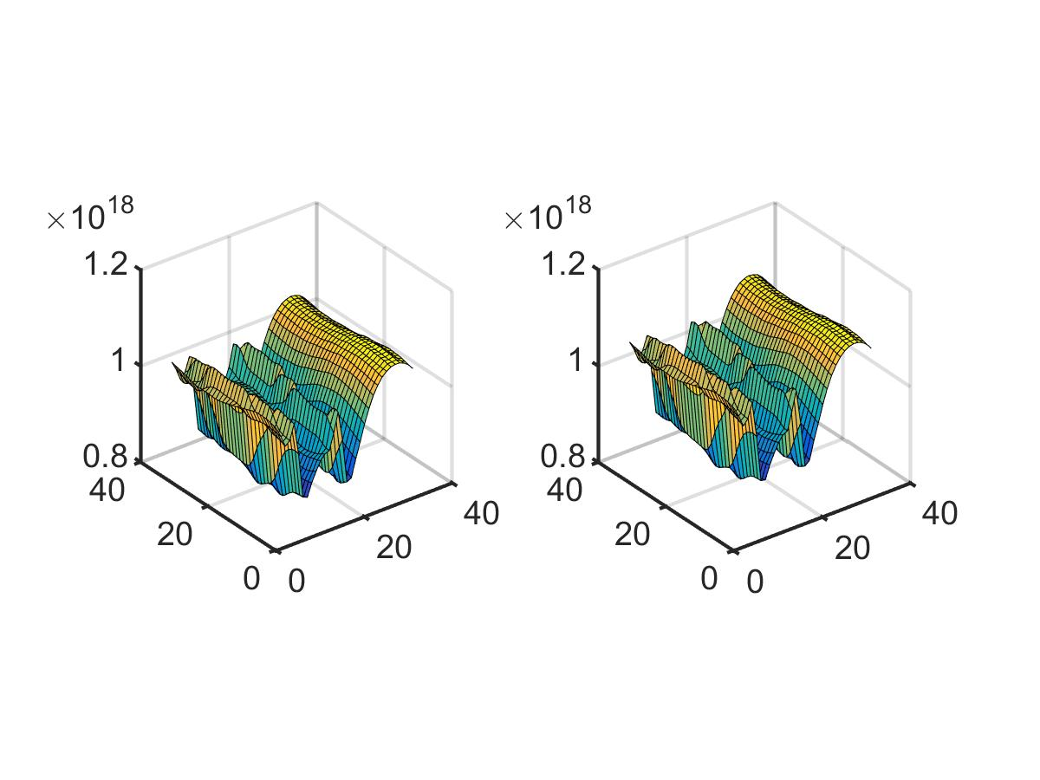

Running on a standard personal computer:

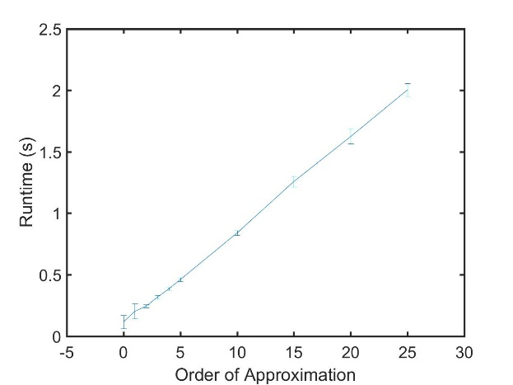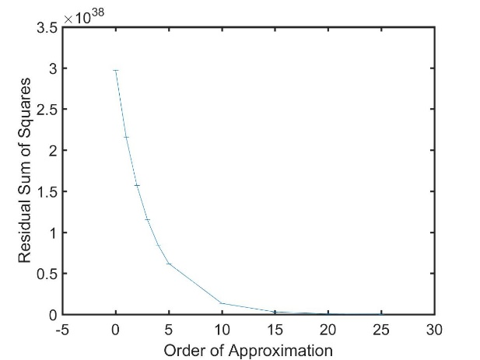

It is proposed in <http://dl.acm.org/citation.cfm?id=1086730> that the substrate/film/air simulation naturally imposes stress free boundary conditions on the film surface and the bottom of the substrate. Fourier transform solution techniques impose periodic boundary conditions. As such, the air layer with wraps the substrate as well as the film. Within the air layer, the elastic tensor, and hence stress, is zero. Continuity of stress implies that the stress is zero at the air/film and the periodically imposed substrate/air interface. A detailed proof is given in <http://dl.acm.org/citation.cfm?id=1086730>